Volume II
Wave 1 Requirements

Table of Contents
1.0 Introduction 3
2.0 Wave One Capability Details 12
2.1 Manage Client & Case Data 13
2.2 Manage My Work 14
2.3 Conduct Collateral Investigations 15
2.4 Manage Activities in Chronos 16
2.5 Manage Client Drug Results & Scheduling 18
2.6 Manage Document Images 19
2.7 Administration 19
2.8 Manage Access to System 20
2.9 Manage Client Check-Ins 21
2.10 Pretrial Services Investigation and Bail Report 21
2.11 PTS Material Witness Investigation 26
2.12 Ad Hoc Pretrial Services Investigation/Report 26
2.13 Manage My Pretrial Investigations 27
2.14 PTS Initial Case Supervision Plan (ICSP) 27
2.15 Pretrial Supervision 28
2.16 Pretrial Noncompliance / Violation Investigation/Report 32
2.17 Manage Release & Detention Orders 32
2.18 Manage New Arrest/Charge Record 33
2.19 PTS Status Report 33
2.20 PTS Supervision Progress Report 33
2.21 PTS Pretrial Diversion Investigation & Report 34
2.22 Diversion Supervision 35
2.23 Prepare for & Attend Court Hearings 37
2.24 Performs Non-Supervision Pretrial Related Activities 38
2.25 Download Pretrial Services Forms 38
2.26 Review Pretrial Services Reports 39
2.27 Manage Witness Security Program (WITSEC) Cases 39
2.28 Data Migration of Existing Legacy PACTS Client Records 39
2.29 Flexible Linking of Client, Cases, Chronos, Documents, and Subject Records 39
2.30 Training Plan and Materials 40
Appendix A – External Systems to Interface 41
Appendix B – User Roles 44

Table of Figures
Figure 1. Pretrial Elements 5
Figure 2. Pretrial Investigation and Bail Report Workflow 23
Figure 3. Pretrial Supervision Workflow 30
Figure 4. Pretrial Diversion Supervision Workflow 35
Figure 5. Pretrial Services Context / Workflow 42
Figure 6. User Roles 43

Introduction
This document contains the capabilities to be included in Wave One of the Probation and Pretrial Services (PPS) Client Management System.
This document has the following sections:
- 1.0 Introduction: Contains a short introduction to the document including a summary of the capabilities described in this document.
- 2.0 Wave One Capability Details: Contains the details of the functional and non-functional capabilities for Wave One.
- Appendix A – External Systems to Interface: Contains a list of external systems (i.e., outside of PPS Client Management System) to which the PPS Client Management System – Wave One needs to interface.
- Appendix B – User Roles: Contains summary of the user roles (both pretrial and post-conviction) of the PPS Case Management System.
The primary focus of the pretrial function, as statutorily defined, is twofold: provide a pretrial services report at time of release decision and provide supervision of defendants released on bond in the least restrictive manner to reasonably assure their presence in court as required and the safety of the community. The system needs to be optimized:
- Primarily for the officer (who performs the pretrial investigations and supervision),
- Secondarily for the supervisor of the officer so that he can ensure that the officer is successfully performing pretrial services, and
- Thirdly to the persons who provide oversite and data quality.
While the system needs to be optimized to the officer's needs, the system should have specific views that are tailored to the needs of the supervisors and oversite personnel.
The system needs to provide for the following:
- Track Activities: The users need to track the activities that they need to do (including due dates and indication of overdue activities) and activities that they have completed. Activities may need to be recorded as chronos for future reference. Activities include:
  - Perform Investigations (Input): Investigations may include interviewing one or more persons, performing research (in internal and external data sources), and may result in communication and/or reports to the court. Examples of pretrial investigations include:
    - pretrial services investigation (which results in a bail report),
    - pretrial diversion investigation (which results in a pretrial diversion report),
    - pretrial noncompliance/violation investigation (which results in a violation report), and
    - collateral investigation.
  - Write Reports (Output): Reports are formal communications created by the user that are delivered to the court or other personnel and may be preceded by a formal investigation. Examples of pretrial reports include:
    - pretrial bail report,
    - pretrial diversion report,
    - pretrial violation report, and
    - Pretrial supervision case plan.
  - Perform Supervision Activities: The pretrial supervision process is an ongoing cycle of investigation, assessment, planning, implementation, and evaluation. Each condition entered in the release order is monitored and addressed where needed. Examples of supervision activities include:
    - Performing home contacts or assessments.
    - monitoring & addresses pretrial conditions/risks,
    - conducting drug & alcohol testing, and
    - monitoring & addressing noncompliance.
- Record Chronos of Activities and Events: Chronos record details of interactions with clients. This includes entries created by the officer in the chronological record surrounding all contacts with the defendant, collateral contacts, documentation, and case events. This also includes chronos that are automatically created by the system as the results of certain triggering events.
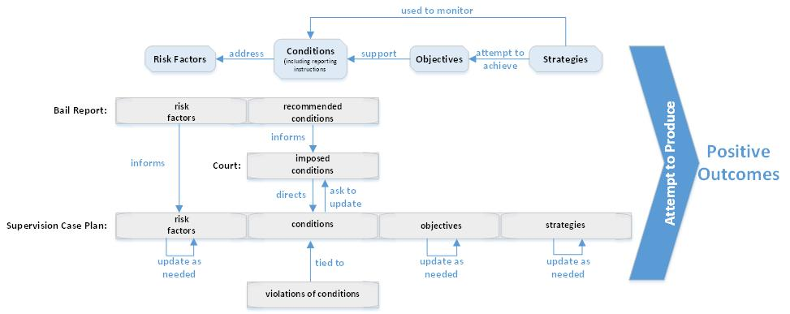
Figure 1. Pretrial Elements
The above diagram depicts elements that are used during pretrial in order to produce positive outcomes and reasonably assure the appearance of the defendant (i.e., client) as required and to assure the safety of any other person and the community. Major pretrial elements include the following:
- Risk Factors are something that increases risk or susceptibility of producing a negative outcome. These negative outcomes include failure to appear / risk of flight, danger to the community, new criminal arrest, or technical violations leading to revocation while on pretrial release. Targeted risk factors are used to identify the particular types of risks presented by the defendant that may signal the need for supervision and/or specific conditions of release to address these risk factors.
- Conditions of release are court-imposed requirements that a defendant must abide by in order to remain under pretrial supervision, as an alternative to imprisonment. For example, refraining from use of illegal drugs is a mandatory condition for everyone under federal supervision; a person who is known to have used illegal drugs in the past may also have regular drug testing as a condition. Conditions establish the behavioral limitations with which the defendant must comply while on pretrial supervision. Conditions address risk factors.
- Objectives are goals for the defendant to accomplish. These concrete objectives describe what the defendant is to accomplish during the period of supervision Objectives supplement the basic behavioral requirements that the defendant commit no new crimes, appear in court as required, and comply with all other conditions of release by providing a road map for what this particular defendant needs to do to accomplish these goals. They are to flow directly from the conditions and risk factors. Objectives support conditions.
- Strategies are a plan of action designed to manage risk during the period of pretrial services and can have the secondary benefit of influencing a defendant’s future choices. Risk factors are evaluated for a defendant and this information is used to develop strategies to implement and monitor compliance with the conditions of release. Strategies attempt to achieve objectives and are used to monitor conditions of release.
- Positive Outcomes include the defendant appearing in court as required, the community being safe, and improving the defendant's future choices, etc. Positive outcomes and the goal of the pretrial process.
- Violations of Conditions are instances when the defendant actions do not conform to the imposed conditions of release. This includes instances when the defendant does something contradictory to what he/she was ordered to do (e.g., no weapons possession) or they fail to do what was ordered of them (e.g., failure to report a change of address). These violations constitute noncompliant behavior. Noncompliant behavior may consist of new criminal activity, failure to appear for court hearings, or failure to meet the requirements of other conditions, commonly known as a technical violation. A violation is tied to one or more release conditions for a defendant.
Risk factors are initially defined by an officer in the bail report. These risk factors inform (i.e., prepopulate) the objectives and strategies used by the supervision officer. The supervision officer updates the risk factors based on new information and new circumstances throughout the period of supervision.
Release conditions are recommended by the officer in the bail report. The court is informed by the recommended conditions and imposes the official conditions (which may be the same or different from the recommended conditions) on the defendant for pretrial supervision (in cases where pretrial supervision is ordered by the court instead of unsupervised release, detention, etc.). These imposed conditions are put into the supervision case plan and usually include defendant reporting instructions (e.g., the defendant will report to the USPO every month between the 1st and the 5th to submit a complete supervision form). If circumstances change and the supervision officer recommends a change in the official/imposed conditions, then they must ask the court for the change(s). The official conditions recorded in the supervision case plan drive the objectives and strategies for that defendant. Violations are tied to specific condition(s).
Evidence-based practices (EBP) are used in Probation and Pretrial Services to help shape what interventions should be used in each case to produce desired outcomes / results. These evidence-based practices should be used to inform pretrial recommendations, as well as objectives and strategies in the supervision case plan. For example, these evidence-based best practices can be used to inform the decision of what strategies should be used for a specific imposed condition or combination of imposed conditions.
The business goals of this system are:
- Extensibility: The system must facilitate local tailoring by individual districts.
- Offline: Critical system functionality must operate when Internet connectivity is not available.
- Accountability: The system must have the ability to detect & track inappropriate and unauthorized access to client data through audit trails.
- Mobility: The system must allow work to be performed where needed, when needed, and on whatever device or browser chosen.
- Data Quality: The system must eliminate data inconsistency, duplication, and redundancy.
- Workflow: The system must be officer workflow based and not Module based.
The term "officer" in this document refers to officers, officer assistants, and others who may be granted permissions to perform such duties.
Below is the list of capabilities in Wave One of the PPS Client Management System. A capability is a high-level solution behavior that can be deployed so that the user has a complete set of steps to achieve a goal.
Capability | Includes
- Manage Client & Case Data | Finding client records, creating/updating general client records, and creating/updating [criminal] case record(s) related to a client.
- Manage My Work | Managing user's own caseload, cases, and action items, as well as managing officer/district employment statistics. Includes that ability to view a tailored dashboard of work.
- Conduct Collateral Investigations | Conducting collateral investigation (by employee in a district other than the sentencing district) to assist the officer conducting the investigation in the district of jurisdiction (i.e., help verify information that could not reasonably be verified by staff in the district of jurisdiction). Record checks are conducted for other districts to find out additional information regarding their defendant's criminal history. This capability includes requesting collateral investigations from other districts. Includes collateral investigations within district by field offices or in-district staff.
- Manage Activities in Chronos | Recording key elements of the client's circumstances and the supervision process, with emphasis on the work done to accomplish the desired outcomes of supervision and the results achieved. This includes documenting details of interactions with a client. Includes entries created by the officer in the chronological record surrounding all contacts with the client, collateral contacts, documentation, and case events.
- Manage Client Drug Results & Scheduling | Managing client drug test results, including managing Prob. 45 contract/non-contract program plans, searching for and viewing client drug test results, assigning/managing drug phases for my clients, reviewing phase calendars, (randomly) generating phase calendars, and managing phase parameters.
- Manage Document Images | Managing the document image (e.g., scanned documents) related to a client in one or more cases. Includes submission of case files to United States Sentencing Commission (USSC).
- Administration | Managing the settings, lists, and preferences (both system wide, district wide, and personal) that drive the system.
- Manage Access to System | Managing the access to and security of the system including management of roles/groups, permissions, user accounts, resetting/changing passwords, as well as login / authentication of valid users.
- Manage Client Check-Ins | Manage a client's check-in (i.e., checking in client for office visit, managing waiting list of clients to be seen, and marking a client as being seen).
- Pretrial Services Investigation and Bail Report | Conducting an investigation / interview of a defendant for bail purposes and the preparing of a report (that provides information to the court) that includes information / recommendations pertaining to the pretrial release of each individual charged with an offense. This includes information relating to any danger that the release of such person may pose to any other person or the community, and, where appropriate, include a recommendation as to whether such individual should be released or detained and, if release is recommended, recommend appropriate conditions of release. This pretrial investigation encompasses the pretrial interview and the activities related to verification of the information provided through collateral contacts with friends, employers, relatives, automated databases (such as credit companies and law enforcement), record checks, and collateral contact with other districts. In other words, when a defendant is summoned to federal court or an arrest warrant is executed, a pretrial services officer initiates an investigation.  The purpose of the pretrial investigation is to determine if the defendant can be released to the community or if there is a danger to the community, or a danger of non-appearance that would warrant not releasing the defendant.
- PTS Material Witness Investigation | A material witness is an individual whose testimony is material to a criminal proceeding. If a party shows that the testimony of a material witness cannot be secured by subpoena, the judicial officer may order the arrest of the person and treat the person in accordance with the release and detention provisions of 18 U.S.C. § 3142. The officer interviews a material witness the same as any defendant. Material witnesses are not referred to as “defendants” because they are not charged with crimes.
- Ad Hoc Pretrial Services Investigation/Report | Officers conduct ad hoc pretrial services investigations and reports to deal with a variety of circumstances. These investigations/reports need to be flexible in format/content and need to be customizable. The format of the ad hoc pretrial services investigations/reports need to be saved and shared (i.e., as an empty template that can be shared).
- Manage My Pretrial Investigations | Managing this user's list of pretrial investigations.
- PTS Initial Case Supervision Plan (ICSP) | The purpose of supervision planning is to create an evolving, individualized, evidence and outcome-based plan of action to monitor the client's compliance with the conditions of release and intervene as necessary to address any identified risks. The desired outcome in all cases is the successful completion of the term of supervision during which the client commits no new crimes, appears in court for all scheduled hearings, and complies with all other conditions of release.
- Pretrial Supervision | Activities related to the supervision of a federal defendant under pretrial supervision. The purpose of pretrial services supervision is to assure compliance with conditions of release and to provide the defendant with services as needed. The pretrial supervision process is an ongoing cycle of investigation, assessment, planning, implementation, and evaluation. Each condition entered in the release order is monitored and where applicable verification may need to be uploaded (e.g., employment verification, surrender of passport, etc.). Treatment referrals may need to be made with appropriate contracting.  Includes conducting home assessments, preparing and approving PTS supervision plan, monitoring & addressing pretrial conditions/risks, providing courtesy PTS supervision, requesting/recording/reviewing PTS drug & alcohol testing, updating the PTS supervision case, and managing noncompliance.
- Pretrial Noncompliance / Violation Investigation / Report | When officers become aware of an apparent violation, they are to conduct a thorough investigation by obtaining relevant documentation and interviewing appropriate parties to verify the information received and explore the context. Activities may include contact with the defendant, defense counsel, law enforcement, and other relevant parties.
- Manage Release & Detention Orders | Managing the release orders and detention orders for a client.
- Manage New Arrest/Charge Record | Managing new arrests or charge records for a client.
- PTS Status Report | Officers conduct an investigation and assessment cycle in order to prepare a Pretrial Services (PTS) Status Report (also called Release Status Report) for the court. This investigation includes a criminal records check. For a defendant that is found guilty of an offense and who is awaiting imposition of a sentence, the officer is directed to determine if and how the conviction impacts continued pretrial release.  The PTS Status Report (Form PS 38) provides a summation of the defendant’s compliance with conditions of release and additional information that will assist the court in determining whether the defendant should be continued on release or detained. The officer submits the PTS Status Report, along with a copy of the pretrial services report, to the judicial officer and to counsel.  This report is typical used for Change of Plea (COP) (i.e., a hearing where defendant's accept a plea deal and we typically provide a status report at the time of plea and sentencing) and Sentencing.
- PTS Supervision Progress Report | The formal evaluation process for the PTS supervision progress report is focused on the progress of the client under pretrial supervision.  This report is typically used with Location Monitoring Program (LMP) cases (i.e., when client have an ankle bracelet with GPS monitoring or something similar) if recommending removal of the LMP condition.
- PTS Pretrial Diversion Investigation & Report | Activities when a pretrial diversion investigation is received from the US Attorney's Office for the pretrial services office to begin a pretrial diversion investigation before a defendant is accepted into the diversion program. The officer prepares a report that guides the United States Attorney's office and the court, as applicable, in making determinations related to the pretrial diversion program. These activities include creating the Diversion Agreement. The diversion process may start either before or after the formal filing of charges; in either case, prosecution is suspended.
- Diversion Supervision | Pretrial diversion is an alternative to prosecution, which seeks to divert certain candidates from traditional criminal justice processing into a program of community supervision administered by the United States Pretrial Services or Probation Office. The diversion process may start either before or after the formal filing of charges; in either case, prosecution is suspended. Participants ("divertees") who successfully complete the pretrial diversion program are not charged or, if they are charged, have the charges against them dismissed; unsuccessful divertees are terminated from the program and may be prosecuted.  Diversion (i.e., probation before judgment) Supervision is the same as Pretrial Supervision except the outcomes are different (diversion happens before trial, get "probation before judgement" and if non-compliant then may go to trial.
- Prepare for & Attend Court Hearings | Prep work before and during court hearings. Scheduling, assignment of court coverage, and court outcome updating of case files.
- Performs Non-Supervision Pretrial Related Activities | Officer duties when a defendant is not released on pretrial supervision and is instead detained or released without supervision. Includes performing follow-up on Detained/Bail Not Made Cases.
- Download Pretrial Services Forms | Download approximately 22 forms related to pretrial. Note that districts can upload local/tailored forms so these forms need to be available for download here.
- Review Pretrial Services Reports | Producing and reviewing approximately 60 PACTS national reports and 230 standard reports related to pretrial.
- Manage Witness Security Program (WITSEC) Cases | Officer activities related to management of Witness Security Program (WITSEC) Cases (i.e., Witness Protection). Only the WITSEC officer manages WITSEC cases. Includes chrono confidential contacts. This process is currently managed offline.

Note that Wave One also needs to support spell checking, usage tracking/audit trail, help, offline usage with subsequent data sync up online, user preferences, alerts/notifications, data migration (where needed for Wave One functionality), data sharing with current systems, and web services.
Note that in this document, the term "Manage" is used when an object (e.g., education information, collateral contact, alternate name, residence, chrono, etc.) needs to be manipulated (e.g., view a list of all residences/addresses for client, create a new residence, view details of a residence, modify the details of a residence, delete a residence, etc.).

Wave One Capability Details
General Critical Needs for Wave One:
- Shall be single client database for all districts so that information recorded for a client in one district can be accessed by officers in another district based on role-based access control (note: right now the client database is compartmentalized so that an officer can only see the client data from their own district).
- Shall reduce the duplicate data entry through data cardinality and maintaining data integrity and enforcement (e.g., data entered in the general client record should not need to be entered again in the bail report).
- Shall be mobile device friendly / accessible.
- Shall be support offline capabilities and data sync feature when end-user reconnects that uploads the information to the system efficiently with data consistency check and data conflict resolution (i.e., need offline data entry with sync).
- Shall be able to handle personalization and user preference capabilities at the end-user level, specific role level, org unit level and at the global system level.
- Shall be configurable to time dimension (e.g., daily, weekly, monthly, etc.) To-Do.
- Shall be configurable to filter and sort based on defined metadata criteria.
- Shall be able to assign/dismiss/reassign based on the role-based access to invite another officer to see one of my clients, and ability to give other districts a "role" in multi-district case. There are instances where the original district loses their role in the cases. Different circumstances include:
  - Rule 5
  - Rule 20
  - Courtesy supervision in and out
- Shall be able to identify multiple districts handling a variety of roles for a client and a specific case:
  - district that does the pretrial supervision,
  - districts that have jurisdiction,
  - district that does the presentence,
  - District with post-conviction supervision, etc.

Manage Client & Case Data
Finding client records, creating/updating general client records, and creating/updating [criminal] case record(s) related to a client. Note that there is an ability to mark a client as "confidential".
Content of Capability:
- Find Client
- Manage Client Record
  - Create New Client Record
  - Manage Client Names and IDs
  - Manage Remarks About Client
  - Manage Residences/Addresses (includes other occupants, hazards, and directions)
  - Manage Contact Information
    - Manage Phone Numbers (date in and date out)
    - Manage Fax Numbers
    - Manage Email Addresses
  - Manage Social Media Accounts
  - Manage Demographics
  - Manage Military History
  - Manage Alternate Names/IDs
    - Manage Alternate Names
    - Manage Alternate IDs
    - Manage Identifying Marks
  - Manage Pretrial Services and Post-Conviction File Location Information
  - Manage Vehicles
  - Manage Photographs
  - Manage Client Profile
    - Manage General Profile Info
    - Manage Education Info
    - Manage Mental Health Info
    - Manage Substance Abuse Info
    - View Profile Summary
    - View Profile History
  - Manage Collateral Contacts
  - Manage Employment Info
  - Manage Unemployment Info
  - Manage Annual Income Tax
  - Manage Other Income Information
  - Review Create Client Record Summary
- Manage Cases for Client (including both active and inactive clients)
- Manage Defendants Related to Case (note that this functionality does not exist now) (i.e., view a list of all co-defendants related to this case, add a new co-defendant (i.e., client) to this case, etc.)

Manage My Work
Managing user's own caseload, cases, and action items, as well as managing officer/district employment statistics. Includes that ability to view a tailored dashboard of work.
Officer Dashboard Should Include:
- my calendar with alerts
- contact requirements from policy of best practices guide (vendor contacts every 30 days)
- due dates for home contacts
- violations
- case plans due dates
- PTRAs
- pending investigations and due dates
- Prob 45 reviews
- positive drug tests
- ATLAS hits (with link to external site)
- CM/ECF (external system) court dates on the calendar
- calendar synced with portable devices
- color coded calendar – with the ability to move items and terminate day
- ability to hover over case and see pop-up of client picture, random urine analysis, DNA, things due, etc.
Supervisor Dashboard Should Include:
- officers assigned to them
- cases pending assignment
- contracts requiring review
- case plans to be reviewed/approved
- bond/bail reports to be reviewed/approved
- CM/ECF court calendar
- outcomes: releases / detentions / revocations / recommendations
- pending investigations
- contact frequency (personal, collateral, etc.)
- noncompliance
- ability to run statistics/analytics on officers under me
Data Quality Admin (DQA) and Clerk Dashboard Should Include:
- my district's caseload statistics (e.g., supervisions, PTS detentions, violations) (e.g., cases activated, inactive)
- data extraction tool
- DSS dashboard of reports (internal analytics)
- calendar (link to email calendar)
- action list for data quality person / clerk
- list of all officers assigned to them and list of the officer's cases (for Clerks)
- links to how to documents and helpful checklists
- blog / Facebook type area for data quality persons / checks to converse on various topics
- SDSO announcements (from support/help desk) for upcoming releases, emergency modification request (EMR) ticket information
- my district's on-demand workload and workload documentation
Content of Capability:
- Manage My Caseload and Statistics
  - Manage My Caseload
  - Manage Officer Employment Statistics
  - Manage District Employment Statistics
- Manage My Cases
- Manage My Action List

Conduct Collateral Investigations
Conducting collateral investigation (by an employee in a district other than the sentencing district) to assist the officer conducting the investigation in the district of jurisdiction (i.e., help verify information that could not reasonably be verified by staff in the district of jurisdiction). Record checks are conducted for other districts to find out additional information regarding their defendant's criminal history. This capability includes requesting collateral investigations from other districts. Includes collateral investigations within district by field offices or in-district staff.
Includes the ability to:
- create new collateral investigation,
- view/modify general information related to collateral investigation,
- view/modify disclosure tracking related to collateral investigation,
- view/modify offense related to collateral investigation,
- view/modify remarks related to collateral investigation,
- view summary of collateral investigation information,
- request collateral investigation to be conducted by another district,
- view list of requested collateral investigations to be conducted by other district,
- view details of collateral investigation conducted by district, and
- submit report to district or office within district.
From Work Center Description: Conducts Collateral Investigation
- This process begins with receipt of request and includes:
  - Screens/assigns investigation
  - Conducts criminal history investigation
  - Conducts other investigation (home assessment, employment assessment, etc.)
  - Collects record and submits investigation
- And, concludes when report is submitted to requesting district / office within district.

Manage Activities in Chronos
The chronological record (i.e., chronos) is the means by which officers document key elements of the client's circumstances and the supervision process, with emphasis on the work done to accomplish the desired outcomes of supervision and the results achieved.
The chronological record also conveys accurate up-to-date information about the case to facilitate:
- communication among officers, supervisors, and office staff who may share responsibility for the case during the period of supervision,
- supervisory oversight of the appropriate application of supervision statutes and policies in each individual case, and
- evaluation of the quality and effectiveness of evidence-based program implementation at office, district, and national levels.
Chronos are used to record details of interactions with a client. Includes entries created by the officer in the chronological record surrounding all contacts with the client, collateral contacts, documentation, and case events.
According to Volume 8 of the Guide to Judiciary Policy, the "chronological record", known as Chronos in PACTS, is a means by which the Officer documents key elements concerning the offender's / defendant's circumstances and the supervision process. A chrono is intended to include meaningful events that describe the status, conduct, and condition of the offender/defendant, the supervision activities undertaken by the officer to implement the supervision plan and respond to identified risk/need issues, and key case processing events that affect the parameters of the supervision term or the supervision plan, like conditions added to or removed by the court or plan staffing.
In addition to chronos about officers monitoring activities there are administrative chronos that are entered as case progresses, monthly report review, any third party contact, letters sent, emails received (i.e., anything that happens in a case).
Officers are required to keep a record of their work under 18 U.S.C. 3603(5). The chronological record is the means by which officers document key elements of the client's circumstances and the supervision process, with emphasis on the work done to accomplish the desired outcomes of supervision and the results achieved. The chronological record is to include only meaningful events that describe:
- The status, conduct, and condition of the defendant/offender;
- The supervision activities undertaken by the officer to implement the supervision plan and respond to identified risk/need issues; and
- Key case processing events that affect the parameters of the supervision term (e.g., conditions added or removed by the court) or the supervision plan (e.g., case staffings).
Need chronos to be created automatically as often as possible. Each chrono needs to contain:
- Who: the contact/event was with (and who the contact was about; e.g., the client, etc.)
- What: the nature for the contact/event – this drives the chrono code
- When: the contact/event occurred
- Where: the contact/event occurred
- Why: the reason/purpose for the contact/event
- Results: the outcome of the contact/event, if any
Contact Code Categories include:
- COLLATERALS
- COURT
- DOCUMENTS
- INQUIRIES
- MONITOR-LOC
- MONITOR-TEST
- NOTIFICATIONS
- PERSONALS
- PLAN-STAFFING
- STARR
- SUMMARIES
There are approximately 150 national chronos in the system. Examples of chronos include (but are not limited to):
- Bond Violation Hearing
- Breathalyzer taken
- Closing Summary
- Collateral Telephone Contact
- Detention Hearing
- DNA Testing
- Email received
- FLASH Initial Notice
- Home Assessment
- Initial Appearance
- Initial case plan finalized as submitted
- Inquiry to Credit Bureau
- Negative Urinalysis
- Positive Urinalysis
- Post-Release Intake Interview
- Sentencing Hearing
Includes the ability to:
- search for chronos / client history,
- filter chronos / client history list (by date, type, confidentiality, category, etc.),
- view the results of a search for chronos / client history,
- create new chronos / client history,
- view/modify chronos / client history,
- view summary of chronos / client history, and
- delete chronos by this author.
There are two overarching kinds of Chronos: System-generated and User-generated.
- System-generated Chronos are Chronos that are created when the user makes any addition or edit in the system that has been flagged as one that shall generate system-generated Chronos. System generated Chronos consist of canned language that explains the transaction that was conducted. Note that the key here is that the user is NOT going through the 'Chronos component' to add the Chrono. That is, the user is NOT selecting Contact/Source, Method, Date and Time on the Chronos page.
- User-generated Chronos are Chronos that are created manually by the user by going to the 'Chronos component' and selecting a Contact/Source, Method, Date, and Time. Narrative, Bin, and Batch Chronos are user-generated Chronos.
  - Narrative Chrono: Users select Contact/Source, Method, Date, Time, and add Narrative text. User has the ability to mark specific chrono as “confidential.” The user has the ability to flag specific chrono as “attempted”, “third-party risk”, “plan change”, “Noncompliance”, and “Response to Noncompliance.”
  - Bin Chrono: Users select Contact/Source, Method, Date, Time, and select 'Start Activity Chrono' button. That user action begins the 'Bin Conversation' with the system, which allows the users to navigate anywhere in the system to edit and add while keeping the 'bin' open. Notice here that any transaction that is flagged as one that shall generate system-generated Chronos will be recorded in the Bin. That is, if users make an edit to Employment, which shall generate a system-generated Chrono, the canned language that comes from the system-generated Chrono will be displayed within the Bin Chrono. Bin Chronos also allow users to enter Narrative.
  - Batch Chronos: Batch Chronos are used when Officers conduct transactions in batches. For example, Officers may want to record that they did a record check on 10 Clients. So, to save Officers some time, they will be able to select a Contact/Source, Method, Date, Time, add all the 10 Clients to the batch Chrono, and then add narrative such as: "conducted record check"

Manage Client Drug Results & Scheduling
Managing client drug results, including managing Prob. 45 contract/non-contract program plans, searching for and viewing client drug test results, assigning/managing drug phases for my clients, reviewing phase calendars, (randomly) generating phase calendars, and managing phase parameters.
Content of Capability:
- Manage Prob. 45 Contract Program Plan
  - Manage Active Post-Conviction Prob. 45 Contract Program Plans
  - Manage Completed Post-Conviction Prob. 45 Contract Program Plans
  - Manage Active Pretrial Prob. 45 Contract Program Plans
  - Manage Completed Pretrial Prob. 45 Contract Program Plans
- Manage Prob. 45 Non-Contract Program Plan
  - Manage Active Post-Conviction Prob. 45 Non-Contract Program Plans
  - Manage Completed Post-Conviction Prob. 45 Non-Contract Program Plans
  - Manage Active Pretrial Prob. 45 Non-Contract Program Plans
  - Manage Completed Pretrial Prob. 45 Non-Contract Program Plans
- Searching for & Viewing Client Drug Test Results
- Manage Drug Phases for My Clients
- Manage Drug Test Phase Schedules / Calendars

Manage Document Images
Managing the document image (e.g., scanned documents) related to a client in one or more cases. Includes submission of case files to United States Sentencing Commission (USSC). Want to be able to:
- link certain document images to certain pages in client record. For instance, proof of the employment on employment page for that employment;
- view documents in context and in single/filterable list to browse;
- perform free text search in the content of the scanned documents (via optical character recognition OCR);
- drag and drop files instead of browse hard drive;
- concatenate a selected set of documents and export them to PDF for travel via mobile device or to send to someone, etc.
Content of Capability:
- View List Of All Cases For This Client
- Manage Document Images
- Manage Quality Control For Document Images Related To Specific Officer
- Manage United States Sentencing Commission (USSC) Packet Transfer
- Manage Packet Transfer To Another District

Administration
Managing the settings, lists, and preferences (both system wide, district wide, and personal) that drive the system.
Content of Capability:
- Administer Data, including:
  - Manage Agency/Courts Data: used to identify organizations (e.g., police departments, sheriff offices, municipal/district courts, etc.) that are referenced in the system
  - Manage Data Tables: used to update database tables (e.g., clients, intakes, conditions, chronos, etc.) (excludes look up tables described below) – it is unclear if the user needs direct access to edit database tables – allows the user to manually edit data in the database
  - Manage Look Up Tables: used to update the lists that are used to populate drop-down menus used to provide predefined responses (e.g., eye color, address type, race, ) – both local values for specific districts and national values used by all districts
  - Manage Chronos Codes: used to manage the chrono codes (including boiler plate / default text for the chrono) used in the system – both local values for specific districts and national values used by all districts, include chrono code canned language
  - Geocode Addresses: used to verify client, co-defendant, and employment addresses that have been entered into the system
  - Move Cases: used to change an existing case docket number – supports the following types of moves: investigations, pretrial services case work, and post-conviction case work
  - Manage Document Imaging Data Lists: used to manage the types of documents that can be uploaded using the document imaging module (including organizing document types into document groups)
  - Manage Pretrial Condition Types: used to create district level pretrial release condition codes (e.g., travel restrictions, obtain no new passport, community service, etc.) and to map them to customizable national categories and codes
  - Manage Special Conditions Types: used to create (district level) special condition codes (e.g., alcohol treatment, drug treatment, no gambling, etc.) that can also be mapped to national categories, as required
  - Manage Staff: used to manage the staff (e.g., officers, data quality analysts, clerks, etc.) within a district including managerial relationships (i.e., superiors and subordinates), pretrial / post-conviction/both designations, location, etc.
  - Manage Standard Conditions Types: used to manage the list of standard conditions of release (e.g., you must not own firearm, not leave judicial district without permission, etc.)
  - Transfer Officer Caseload: used to transfer clients from one officer to another within the same district.
  - Application Programming Interface (API): used to upload XML data files into the database, view files on server, upload files to the server, view error logs, admin job scheduler, chron job scheduler, etc. – it is unclear if this functionality will still be needed
  - Delete Case, Case-Defendants, or Client: used to permanently delete top-level case, case-defendant, and client records, including each related records (this is a highly restricted feature)
  - Modify Menu: used to customize the system menu tree for individual users based on their current permissions
  - Manage Report Canned Language: used to manage all the canned language used in the bail and presentence reports – both local values for specific districts and national values used by all districts
- Customize My PACTS Mobile Preferences (iPACTS)
- Manage Drug Test Definitions (e.g., panels, LTL/NTL import errors, test sites)
- Manage National PACTS Report Transaction (NPR) Data Extractions
- Manage Schedule of Drug Test Phases
- Upload Forms

Manage Access to System
Manage the access to and security of the system including management of roles/groups, permissions, user accounts, resetting/changing passwords, as well as login / authentication of valid users.
A user is a person who operates the system. Some hypothetical examples of users are:
- Tom Smith who works for the District of New Jersey Pretrial Services
- Dakota Jones who works for the Northern District of Alabama Probation Office
- Harry Chung who works for the Central District of California Probation Office
- Sam Roberts who works for the Southern District of Ohio Probation Office
A permission is an action that a user is allowed to perform in the system. A role is a named collection of permissions that allow a user to perform a set of functions in the system. Some hypothetical examples of roles are:
- Tom could have the role of Pretrial Officer
- Dakota could have the role of Data Quality Analyst
- Harry could have the role of Post-Conviction Officer
- Sam could have the role of Supervisor of Officer (aka Supervising United States Probation Officer SUSPO) (every district)
An authenticated user is a user that has logged in to the system with valid the system user ID and password therefore he/she has proved that he/she is who they say they are. An authorized user is a user with correct permissions to perform an action. In this document, a valid user is considered to be an authenticated and authorized user unless noted otherwise (i.e., he/she has correctly identified themselves and has permission to do what he/she is attempting to do).
A permission is akin to a key because it gives access to a specific feature (i.e., a specific door). A role is akin to a key ring that collects many keys (i.e., permissions) that typically are used together or are used by the same kind of user. A user will have one or more key rings (i.e., roles) that define the complete set of features to which they have access. Once a user has proved that they are who they say they are (i.e., they have successfully logged into the system) then they are free to enter any door (i.e., use any feature) for which they have keys (i.e., permissions) on their key ring(s) (i.e., role(s)).
See Appendix C – User Roles for descriptions of these example user roles,

Manage Client Check-Ins
Manage a client's check-in (i.e., checking in client for office visit, managing waiting list of clients to be seen, and marking a client as being seen).
Current Application: PACTS
Content of Capability:
- Check-In Client for Office Visit
- Manage Waiting List of Clients to Be Seen
- Mark Client as Being Seen

Pretrial Services Investigation and Bail Report
Conducting an investigation / interview of a defendant for bail purposes and the preparing of a report (that provides information to the court) that includes information / recommendations pertaining to the pretrial release of each individual charged with an offense. This includes information relating to any danger that the release of such person may pose to any other person or the community, and, where appropriate, include a recommendation as to whether such individual should be released or detained and, if release is recommended, recommend appropriate conditions of release. This pretrial investigation encompasses the pretrial interview and the activities related to verification of the information provided through collateral contacts with friends, employers, relatives, automated databases (such as credit companies and law enforcement), record checks, and collateral contact with other districts. In other words, when a defendant is summoned to federal court or an arrest warrant is executed, a pretrial services officer initiates an investigation.
The purpose of the pretrial investigation is to determine if the defendant can be released to the community or if there is a danger to the community, or a danger of non-appearance that would warrant not releasing the defendant.
As 18 U.S.C. § 3154(1) states, the officer will: collect, verify, and report to the judicial officer, prior to the pretrial release hearing, information pertaining to the pretrial release of each individual charged with an offense, including information relating to any danger that the release of such person may pose to any other person or the community, and, where appropriate, include a recommendation as to whether such individual should be released or detained and, if release is recommended, recommend appropriate conditions of release. This pretrial investigation encompasses the pretrial interview and the activities related to verification of the information provided through collateral contacts with friends, employers, relatives, automated databases (such as credit companies and law enforcement), record checks, and collateral contact with other districts. In other words, when a defendant is summoned to federal court or an arrest warrant is executed, a pretrial services officer initiates an investigation. The collected information against the defendant is used by federal courts to determine a pretrial status (release and/or detention).
The purpose of the pretrial investigation is to determine if the defendant can be released to the community or if there is a danger to the community or a danger of non-appearance that would warrant not releasing the defendant. The defendant can submit a "release plan" and the pretrial officer must investigate that plan to see if it is appropriate. This is different and distinct from verification of information contained within the bail report.
Note that mandatory conditions of release include:
  - The defendant must not commit a Federal, State, or local crime during the period of release.
  - The defendant must cooperate in the collection of a DNA sample from the defendant if the collection of such a sample is authorized pursuant to Section 3 of the DNA Analysis Backlog Elimination Act of 2000.
  - The defendant must immediately advise the court, defense counsel, and the United States attorney in writing before any change in address or telephone number.
  - The defendant must appear in court as required and must surrender to serve any sentence imposed.
  - The defendant is to provide advance notification of any change in residence and/or telephone number.
Note that a Pretrial Officer may have to prepare the bail report without interviewing the client. For example, after notification (and before intake), an officer may have to immediately go to the initial hearing (for plea and initial detain/release decision). Then the officer performs intake, pretrial interview & investigation, etc. and then there is a separate detention hearing to reevaluate decision after investigation is complete.
There are also other situations where a defendant is never interviewed. We prepare hundreds of reports/week where the defendant is simply not interviewed because they are an illegal alien. Also, sometimes defendants will decline the interview, and they may not change their minds later on.
In some cases, (usually related to summons case) the officer is notified well in advance of the initial appearance (IA) so the entire investigation usually takes place beforehand.
Enough information is gathered so that the Pretrial Officer can make an informed recommendation (e.g., release or detain, release options, detention options) based on the clients risk of non-appearance and danger to the community.
Many times, the interview takes place in a location without reliable internet access. Therefore, the answers to the interview questions currently have to be recorded on a paper copy of the PS2 form and typed into the computer when the Pretrial Officer returns to his office. This system needs to be mobile friendly and there needs to be a capability to record answers on a mobile device off-line with a sync feature that uploads the information into PACTS quickly.
This process (of performing the interview and preparing bail report) needs to be completed very quickly (i.e., usually just a couple of hours). Therefore, this process needs to eliminate as much wasted time as possible (e.g., writing answers on paper and then typing them into the computer). This needs to be an ultra-streamlined process. Need to be able to fill in these investigation reports very quickly. Sometimes user needs to process 70+ reports a morning. Large volume requires a quick turnaround. Want ability to batch create bail reports (expedited bail reports for illegal reentry cases).
An addendum to a pretrial services bail report needs to be created if the associated pretrial bail report has been finalized.
From Work Center Description: Conducts Investigation and Prepares Report (exclude interview)
- This process begins after the interview with client and includes:
  - Obtains client information and conducts client bail suitability verification (e.g. corroboration with family, 3rd party custodians, co- signers, criminal history and other data base inquiries, contact with stakeholders)
  - Staffs case with specialist for possible Substance Abuse/Mental Health Treatment/ and/or Placement in the Location Monitoring Program
  - Completes Pretrial Risk Assessment (PTRA) (using external system (RA))
  - Prepares pretrial services report (PSX / MSWORD)
  - Conducts mental health and medical follow-up with detaining agency
  - Completes PACTS data entry and file set-up
  - Makes collateral requests, as needed
  - Performs collateral investigations, as needed
  - Conducts home investigation/assessment
  - Conducts ongoing detention review and investigation
  - Finalize report (SUSPO approval)
- And, concludes when the Court has made a release or detention decision. And sometimes it will even continue beyond the release decision if new pertinent information is obtained.
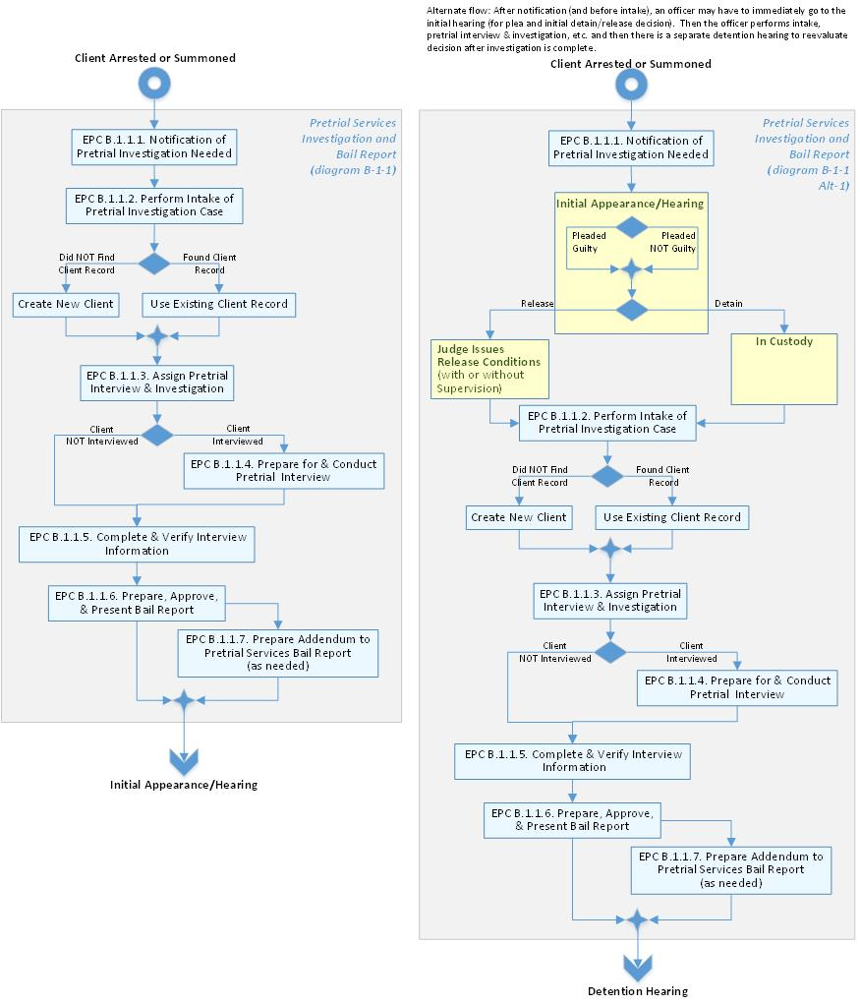
Figure 2. Pretrial Investigation and Bail Report Workflow
Content of Capability:
- Notification of Pretrial Investigation Needed
- Performs Intake of Pretrial Investigation Case
  - Manage Intake of Client - Opening Info
  - Manage Intake of Client - Interview/Report Info
  - Manage Intake of Client - Charged and Convicted Offenses
  - Manage Intake of Client - Priors
  - Manage Intake of Client - Closing Info
  - Manage Intake of Client - Summary Info
- Create & Assign Pretrial Interview & Investigation
- Prepare for & Conduct Pretrial Interview
  - Prepare for Pretrial Interview
  - Conduct Pretrial Interview
    - Conduct Pretrial (PT) Interview Using Electronic Form
      - Manage Pretrial Interview/Bail Report
      - Manage PT Interviewer Notes
      - Manage PT Pretrial Header Info
        - Manage PT Offender Case Information
        - Manage PT Court Name
        - Manage PT Alternate Name(s) on Charging Document
        - Manage PT Charged Offense(s) in Charging Document
      - Manage PT Interview Info
      - Manage PT Defendant History
        - Manage PT Court Name 2
        - Manage PT Alternate Name(s)
        - Manage PT Client IDs
        - Manage PT Alternate ID(s)
        - Manage PT Demographics Info
        - Manage PT Identifying Mark(s)
        - Manage PT Travel Data
        - Manage PT Travel History
        - Manage PT Residence Info
        - Manage PT Education History
        - Manage PT Military History
        - Manage PT Collateral Contact Info
      - Manage PT Employment Info
        - Manage PT Employment History
        - Manage PT Other Income Info
      - Manage PT Financial Info
        - Manage PT Asset & Liability Info
        - Manage PT Monthly Income & Expense Info
        - Manage PT Bankruptcy Info
      - Manage PT Physical Health Info
      - Manage PT Mental Health & Treatment Info
      - Manage PT Substance Abuse & Treatment Info
      - Manage PT Criminal Info
        - Manage PT Criminal History
        - Manage PT Criminal Records
        - Manage PT Gang History
      - Manage PT Assessment of Non-Appearance
      - Manage PT Assessment of Danger
      - Manage Pretrial (PT) Recommendation
    - Conduct Pretrial (PT) Interview Using Paper Form (PS2)
- Complete & Verify Interview Information
- Prepare, Approve, & Present Bail Report
  - Prepare Pretrial Services Bail Report in MS Word
  - Review & Approve Bail Report
  - Present / Deliver Bail Report
- Prepare Addendum to Pretrial Services Bail Report

PTS Material Witness Investigation
A material witness is an individual whose testimony is material to a criminal proceeding. If a party shows that the testimony of a material witness cannot be secured by subpoena, the judicial officer may order the arrest of the person and treat the person in accordance with the release and detention provisions of 18 U.S.C. § 3142. The officer interviews a material witness the same as any defendant. Material witnesses are not referred to as “defendants” because they are not charged with crimes.
No material witness may be detained because of an inability to comply with any condition of release if 1) his or her testimony can adequately be secured by deposition and 2) further detention is not necessary to prevent a failure of justice. Release of a material witness may be delayed for a reasonable period of time until the deposition of the witness can be taken pursuant to the Federal Rules of Criminal Procedure. Material witness supervision is managed the same as PT supervision, but no case plan required.
The PTS material witness investigation is used to capture events that transpire throughout the material witness pretrial process. The Worksheet for Pretrial Services Report (PS2) will guide you with the appropriate coding. Includes the ability to:
- create new material witness PTS investigation for a specific client,
- view list of all material witness PTS investigations for a specific client,
- view / modify material witness PTS investigation for a specific client,
- delete material witness PTS investigation for a specific client, and
- view summary of material witness PTS investigation for a specific client.

Ad Hoc Pretrial Services Investigation/Report
Officers conduct ad hoc pretrial services investigations and reports to deal with a variety of circumstances. These investigations/reports need to be flexible in format/content and need to be customizable. The format of the ad hoc pretrial services investigations/reports need to be saved and shared (i.e., as an empty template that can be shared). Some examples of ad hoc pretrial services investigations/reports include (but are not limited to):
- new residence assessment,
- home assessment,
- employment verification,
- specific condition investigation (e.g., check internet/cable has truly been removed from the home),
- juvenile defendants,
- third-party custodian reviews,
- etc.

Manage My Pretrial Investigations
Managing this user's list of pretrial investigations. Includes the ability to:
- view list of all my active pretrial investigations (including due date),
- view list of all my completed pretrial investigations,
- view details of specific pretrial supervision, and
- view details of specific client related to one of my pretrial supervisions,

PTS Initial Case Supervision Plan (ICSP)
The purpose of supervision planning is to create an evolving, individualized, evidence and outcome-based plan of action to monitor the client's compliance with the conditions of release and intervene as necessary to address any identified risks. The desired outcome in all cases is the successful completion of the term of supervision during which the client commits no new crimes, appears in court for all scheduled hearings, and complies with all other conditions of release.
The pretrial supervision process is an ongoing cycle of investigation, assessment, planning, implementation, and evaluation during which the officer is to:
- investigate and assess the risk issues in the individual case,
- in conjunction with the defendant, set specific objectives to be accomplished by the defendant,
- develop and implement appropriate supervision strategies,
- adjust swiftly and appropriately to any change in circumstances, and
- evaluate the plan on an ongoing basis.
Supervision planning is a fluid process. As the defendant's circumstances change, the officer adjusts the supervision plan and keeps the court informed as appropriate. Supervision case plan is a living document and is frequently updated. Need to be able to see history of changes to case plan, need to see connection between conditions and violations of those conditions. Need ability to create/launch new noncompliance next to each condition and prepopulate based on that condition.
Content of Capability:
- View PTS Supervision Case Plan Summary
- EPC - Manage PTS Supervision Case Plan Conditions
  - Manage PTS Treatment / Counseling Related Conditions
  - Manage PTS Training Related Conditions
  - Manage PTS Supervision Reporting Related Conditions
  - Manage PTS Custodian Conditions
  - Manage PTS Financial / Service Related Conditions
  - Manage PTS Location Related Conditions
  - Manage PTS Employment Related Conditions
  - Manage PTS Association Related Conditions
  - Manage PTS Miscellaneous Restrictions
  - Manage PTS Search/Seizure Conditions
  - Manage PTS Computer / Internet Conditions
  - Manage PTS Other Conditions
- Perform Defendant Assessment (now performed in external system PTRA)
  - View Client Risk Category
  - Manage Clients Risk Prediction Index (RPI) [this may be obsolete]
  - Manage Targeted Risks
  - Manage Substance Abuse Risks
  - Manage Mental Health Risks
  - Manage Danger To Another Person Risks
  - Manage Sex Offender Registration Risk
  - Manage Other Identified Needs
- Manage Reporting Instructions
  - Manage In-Person Reporting Contacts Conditions
  - Manage Telephone Reporting Contacts Conditions
  - Manage Mail Reporting Contacts Conditions
  - Manage Internet Reporting Contacts Conditions (not available in the current system)
- Manage Objectives & Strategies
  - Manage Criminal Patterns / Violence Objectives & Strategies
  - Manage Substance Abuse Objectives & Strategies
  - Manage Mental Health Objectives & Strategies
  - Manage Employment / Financial Objectives & Strategies
  - Manage Education Objectives & Strategies
  - Manage Family / Community Support Objectives & Strategies
  - Manage Medical Objectives & Strategies
  - Manage Legal Objectives & Strategies
  - Manage Basic Needs Objectives & Strategies
  - Manage Referral Records
  - Manage Supervision Focus
- Manage Noncompliance Summary Information
- View PTS Supervision Case Plan Associated Case Information

Pretrial Supervision
Activities related to the supervision of a federal defendant under pretrial supervision. The purpose of pretrial services supervision is to assure compliance with conditions of release and to provide the defendant with services as needed. The pretrial supervision process is an ongoing cycle of investigation, assessment, planning, implementation, and evaluation during which the officer is to:
- investigate and assess the risk issues in the individual case,
- in conjunction with the defendant, set specific objectives to be accomplished by the defendant,
- develop and implement appropriate supervision strategies,
- adjust swiftly and appropriately to any change in circumstances, and
- evaluate the plan on an ongoing basis.
Each condition entered in the release order is monitored and where applicable verification may need to be uploaded (e.g., employment verification, surrender of passport, etc.). Treatment referrals may need to be made with appropriate contracting.
Includes conducting home assessments, preparing & approving PTS supervision plan, conveying conditions / reporting instructions to defendant, monitoring & addressing pretrial conditions/risks, providing courtesy PTS supervision, requesting/recording/reviewing PTS drug & alcohol testing, updating the PTS supervision case, and managing noncompliance.
There is still pretrial supervision after conviction and before what we consider to be post-conviction supervision (it is really post sentencing supervision).
Officers need to take the following actions in response to noncompliance:
- Intervene with both risk control strategies to hold the defendant accountable and to deter further noncompliance, and also with risk reduction strategies to help prevent further noncompliance and to promote success during the period of supervision.
- As required, report violations to the court and the United States attorney and recommend action proportionate to the degree and level of noncompliance.
- Document the noncompliance and each of the above actions in the chronological record.

The officer needs to monitor/supervise the case until the defendant’s voluntary surrender.
Pretrial Supervision flow:
- No violation up to plea/sentencing or trial
  - Go to trial
- Violation before plea, sentencing, or trial (noncompliance investigation)
  - Manage noncompliance - continue to supervise
  - Noncompliance hearing
    - Revoke supervision/bond and detain until trial
    - Modify conditions and continue supervision until trial
    - Create No Action Recommended Volition Report (make no changes until another violation or until trial)
From Work Center Description: Prepares for and Conducts Supervision (in no particular order):
- This process begins with notification of release/case assignment and includes:
  - Reviews file material (bail report, bond conditions, etc.)
  - Participate in issue-driven case staffing
  - Prepares and reviews case supervision plans
  - Makes treatment referrals and follow up
  - Reviews/monitors supervised release files (SRF)
  - Conducts collateral contacts (face-to-face, phone, email) (i.e., anyone other than defendant)
  - Performs Post-Release Intake Interview (PRII)
  - Provides reporting instructions to defendant
  - Takes photo of defendant
  - Schedules home assessment
  - Performs home assessment
  - Regularly reviews conditions with defendant
  - Reminds defendant about upcoming court dates
  - Investigates noncompliance
  - Prepares and submits supervision-related reports and correspondence to court/other district (status reports, bond violations, bond modifications, rule 5 or 20 transfers etc.)
  - Attends hearing
  - Receives monthly supervision reports/ERS entries and make any needed changes to PACTS.
  - Reviews treatment related activities (monthly reports, direct contact with provider)
  - Monitors bond compliance (includes weapons, financial documents)
  - Executes location monitoring program (LMP) (includes activation, installation, review of daily summary/mapping/reports, investigating alerts, scheduling, contact with third parties/collaterals)
  - Prepares for field and office contact
  - Conducts face-to-face contact with client in office and field (e.g., home, employment, treatment visits)
  - Reviews and executes intake activities with client (e.g., reporting instructions, establish collateral contacts, etc.)
  - Administers assessment tools (i.e., TCUDS, SASSI)
  - Conducts urinalyses
  - Conducts plain view seizure activities
  - Addresses noncompliance
  - Explains condition(s) and process
  - Updates PACTS (case set up/chronos/contracts/upload documents, etc.)
  - Oversees any duties associated with released unsupervised cases
  - Enters chronological record
- And, concludes when case is closed.
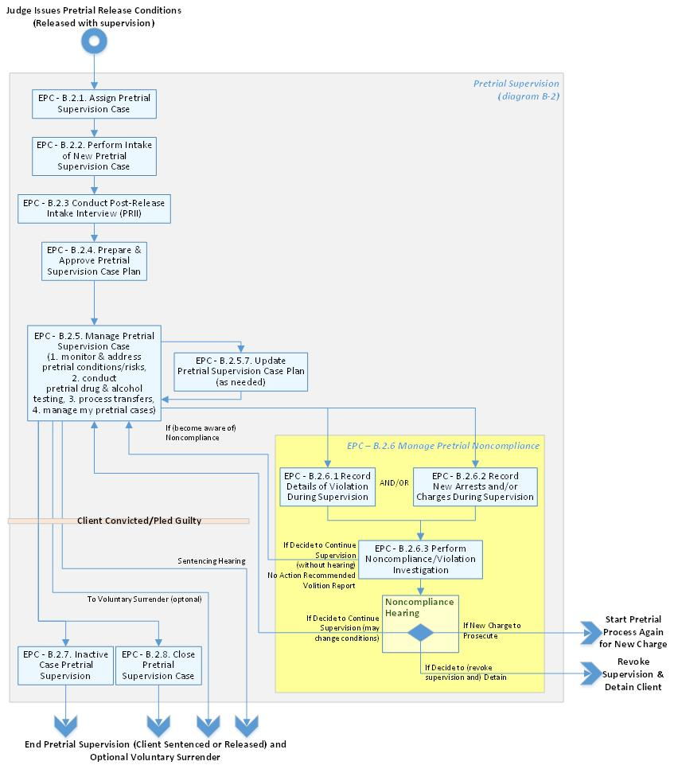
Figure 3. Pretrial Supervision Workflow
Content of Capability:
- Assign Pretrial Supervision Case
- Perform Intake of New Pretrial Supervision Case
- Conduct Post-Release Intake Interview
  - Complete Release Forms
  - Conducting Home Assessment
  - Upload Photo
- Prepare & Approve Initial Pretrial Supervision Case Plan
  - Prepare Supervision Case Plan
  - Review/Approve Case Plan
- Manage Pretrial Supervision Case
  - Monitor & Address Pretrial Conditions/Risks
  - Provide Courtesy Pretrial Supervision (Courtesy-In)
  - Conduct Pretrial Drug and Alcohol Testing
    - Record Drug Test Results
  - Process Within Office/District Transfers
    - Record Transfer
  - Manage My Pretrial Services Cases
  - Update Pretrial Case Plan
  - Manage Client on Courtesy Pretrial Supervision by Another District (Courtesy-Out)
- Manage Pretrial Noncompliance
  - Record Details of Violation During Pretrial Supervision
  - Perform Pretrial Noncompliance/Violation Investigation
  - Record New Arrests and/or Charges During Pretrial Supervision
- Inactivate Pretrial Supervision Case
- Close Pretrial Supervision Case

Pretrial Noncompliance / Violation Investigation/Report
When officers become aware of an apparent violation, they are to conduct a thorough investigation by obtaining relevant documentation and interviewing appropriate parties to verify the information received and explore the context. Activities may include contact with the defendant, defense counsel, law enforcement, and other relevant parties.
All violations start as a potential violation. After an investigation, it may then be marked as not a violation or a reportable violation. This reported violation is reported to the court. At this point, if it is a reportable violation, the process is closed by recording results of hearing / judicial decision related to that reported violation. Need to relate the judicial decision with the release / detention order. Need to be able to easily update release / dentition order and connect it to the violation. Need to easily update conditions after the hearing.

Manage Release & Detention Orders
Managing the release orders and detention orders for a client.

Manage New Arrest/Charge Record
Managing new arrests or charge records for a client.

PTS Status Report
Officers conduct an investigation and assessment cycle in order to prepare a Pretrial Services (PTS) Status Report (also called Release Status Report) for the court. This investigation includes a criminal records check. For a defendant that is found guilty of an offense and who is awaiting imposition of a sentence, the officer is directed to determine if and how the conviction impacts continued pretrial release.
The PTS Status Report (Form PS 38) provides a summation of the defendant’s compliance with conditions of release and additional information that will assist the court in determining whether the defendant should be continued on release or detained. The officer submits the PTS Status Report, along with a copy of the pretrial services report, to the judicial officer and to counsel.
This report is typical used for Change of Plea (COP) (i.e., a hearing where defendant's accept a plea deal and we typically provide a status report at the time of plea and sentencing) and Sentencing.
The PTS Status Report is to:
- inform the court of the conditions under which the defendant was released,
- inform the court of the defendant’s compliance with conditions of release,
- identify risk-related case problems affecting compliance with release conditions,
- describe officer supervision strategies to monitor conditions and address risks,
- assess the defendant’s performance on release, and
- recommend that the defendant’s release conditions remain unchanged, be modified, or be revoked as supported by the information contained in the report.

PTS Supervision Progress Report
The formal evaluation process for the PTS supervision progress report is focused on the progress of the client under pretrial supervision.
This report is typical used with Location Monitoring Program (LMP) cases (i.e., when client have an ankle bracelet with GPS monitoring or something similar) if recommending removal of the LMP condition.
The formal evaluation process is designed to utilize the combined professional expertise of officers, supervisors, and office specialists to:
- assess defendant compliance and progress towards accomplishing objectives,
- evaluate the effectiveness of selected strategies,
- determine what, if any, changes to the plan are warranted, and
- determine if recommendations for modifications to the conditions of release are warranted.
Officers are to prepare for the review by conducting a criminal record check, reviewing the chronological record, and evaluating
- any changes (additions, removals, modifications) to the conditions of release,
- the status of all current conditions, and
- the defendant’s compliance with conditions and progress in meeting supervision objectives.

PTS Pretrial Diversion Investigation & Report
Activities when a pretrial diversion investigation is received from the US Attorney's Office for the pretrial services office to begin a pretrial diversion investigation before a defendant is accepted into the diversion program. The officer prepares a report that guides the U.S. Attorney's Office and the court, as applicable, in making determinations related to the pretrial diversion program. These activities include creating the Diversion Agreement. The diversion process may start either before or after the formal filing of charges; in either case, prosecution is suspended. Sometimes get large groups of diversions in one day. Need to be able to expedite.
From Work Center Description: Prepares Pretrial Services Diversion Report
- This process begins with receiving referral from AUSA, the supporting documents and includes:
  - Receives diversion referral
  - Conducts diversion interview
  - Investigates diversion case
  - Prepares diversion report
- And, concludes with dissemination of report to appropriate parties.

Diversion Supervision
Pretrial diversion is an alternative to prosecution, which seeks to divert certain candidates from traditional criminal justice processing into a program of community supervision administered by the United States Pretrial Services or Probation Office. The diversion process may start either before or after the formal filing of charges; in either case, prosecution is suspended. Participants ("divertees") who successfully complete the pretrial diversion program are not charged or, if they are charged, have the charges against them dismissed; unsuccessful divertees are terminated from the program and may be prosecuted.
Diversion (i.e., probation before judgment) Supervision is the same as Pretrial Supervision except the outcomes are different (diversion happens before trial, get "probation before judgement" and if non-compliant then may go to trial.
Diversion conditions are imposed by US Attorney, not a judge. Diversion conditions are often more intense and require goal-directed interventions by the officer (Risk-Needs-Responsivity model much like post-conviction).
Diversion Supervision flow:
- Client may have admitted guilt
- No violation up to end of supervision period
  - Release without prosecution
- Violation before end of supervision period (noncompliance investigation) – could be new arrest
  - Manage noncompliance - continue to supervise
  - Noncompliance hearing
    - Revoke supervision & prosecute
    - Modify conditions & continue supervision until end of supervision period
    - Do nothing until another violation or until end of supervision period
From Work Center Description: CONDUCTS PRETRIAL DIVERSION SUPERVISION (INCLUDES WITNESS SECURITY (WITSEC))
- This process begins with notification of diversion request and includes:
  - Supervises diversion client
  - Closes diversion case
- And, concludes when case is closed.
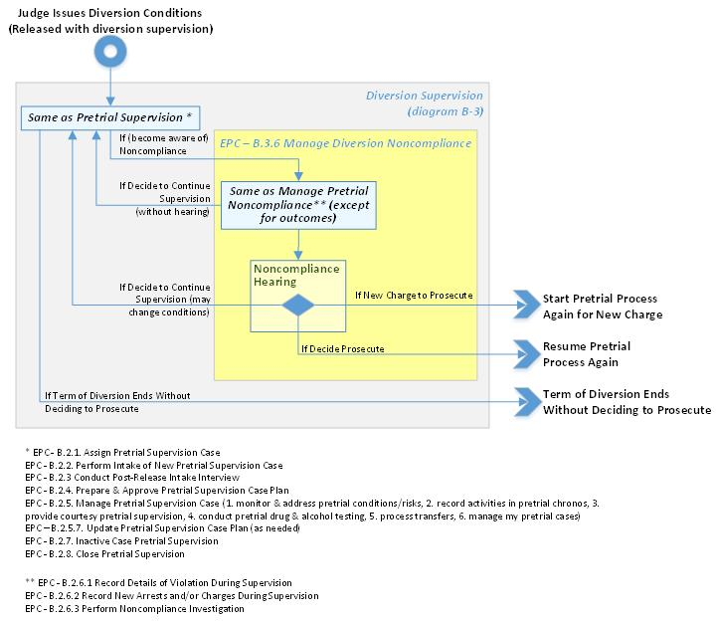
Figure 4. Pretrial Diversion Supervision Workflow

Prepare for & Attend Court Hearings
Prep work before and during court hearings. Scheduling, assignment of court coverage, and court outcome updating of case files.
From Work Center Description: Prepares for and attends hearing (excludes supervision related hearing such as modification/violation hearing, but includes bail (detention) hearings related to supervised release violators)
- This process begins with receiving notice of hearing and includes:
  - Reviews docket/court calendar and ensure coverage where needed
  - Prepares supplements / addendums when necessary
  - Chronos hearing and staffs hearing with assigned officer
  - Provides defendant with release instructions
  - Updates bail report (i.e., prepare addendum)
  - Consults with stakeholders associated with case (e.g., supervising officer, judge, AUSA, defense counsel, collateral contacts)
  - Gathers all pertinent documents
  - Distributes and retrieves bail reports
  - Takes notes of proceedings, testifies, answer inquiries, and codes worksheets
  - Updates PACTS
  - Obtains relevant documentation (i.e. bond, conditions, etc.) and provide defendant with instructions
- And, concludes with court adjournment and/or satisfaction of bond documents.
In order to prepare for court hearings, an officer needs to:
- create a report,
- perform staffings (i.e., meet with colleagues),
- print out chronos,
- create a summary / review sheet to use in court,
- make all the calls to set things up, and
- print documents that support violation or do on iPAD.
Want to see summary page/dashboard for a client before going to a court hearing, including:
  - issues of noncompliance at glance,
  - status,
  - important information,
  - services they have been in,
  - original arrest,
  - reporting schedule, etc.
Content of Capability:
- Prepares for and Attends Arraignment
- Prepares for and Attends Detention Hearings/Bail Reviews Hearings
- Prepares for and Attends Initial Hearing
- Prepares for and Attends Violation Hearings
  - Record Details of Violation
  - Record New Arrests and/or Charges
  - Record Violation Hearing

Performs Non-Supervision Pretrial Related Activities
Officer duties when a defendant is not released on pretrial supervision and is instead detained or released without supervision. Includes performing follow-up on Detained/Bail Not Made Cases.
From Work Center Description: Conducts Non-Client Specific Pretrial Supervision Activities (not related to a specific client)
- This process begins when need is determined and includes:
  - Develops community resources and contact
  - Conducts/facilitates curriculum group session
  - Prepares for travel (e.g., check safety gear, sign-out government vehicle, MapQuest trip)
  - Performs ATLAS SRF activities
  - Generates and reviews DSS Reports
  - Performs BOP group visit
  - Collaborates with local law enforcement
  - Performs batch scanning
- And, concludes with appropriate action.
Content of Capability:
- Performs Follow-up on Detained/Bail Not Made Cases
- View Contract Reference Guide of Treatment Service providers
- View Community Resource Guide Manual
- Manage Vendor Load (e.g., define catchment area for particular service so spread out the referrals over different vendors)
- Suggest Referrals Based on Type of Service Needed and Location (e.g., 3 miles from defendant's home, 10 miles, etc.)
- Print Summary Sheet for Activity (e.g., go to pretrial related hearing, have meeting with client in office, have meeting with client at their home, etc.)
- Assign Officer Based on Client Mapping
- Manage Officer Rotation (e.g., duty officer) Calendar
- Manage Inventory for Safety Gear (e.g., guns, bulletproof vests, batons. etc.)
- Manage Location Monitoring Equipment (i.e., check in and check out).
- Manage Officer In/Out Board
- Manage Surrendered Items (i.e., record where items such as surrendered passports, medical marijuana card, etc. are stored (i.e., a passport inventory).

Download Pretrial Services Forms
Download approximately 22 forms related to pretrial. Note that districts can upload local/tailored forms so these forms need to be available for download here. See subsection 2.7 Administration for details of uploading local forms. Need to prepopulate a form with data related to the current client.

Review Pretrial Services Reports
Producing and reviewing approximately 60 PACTS national reports and 230 standard reports related to pretrial. Need to be able to create newly configured reports. Need to use current data for reports.

Manage Witness Security Program (WITSEC) Cases
Officer activities related to management of Witness Security Program (WITSEC) Cases (i.e., Witness Protection). Only the WITSEC officer manages WITSEC cases. Includes chrono confidential contacts. This process is currently managed offline. Need a different instance of system for WITNESS SECURITY (WITSEC) with different and completely separate database. Regular system is not compartmentalized by district but the WITSEC databases would be compartmented by district.

Data Migration of Existing Legacy PACTS Client Records
As part of PPS-CM platform solution standup includes PPS-CM’s legacy data migration from current PACTS to new PPS-CM platform solution in an On-Premises RDBMS (target database). The Contractor shall migrate test data from the legacy environments to the CM platform test environment, and shall use this test data to demonstrate their data migration process. The migrated data will contain all domains such as client, cases, Chronos, other case reports, subject records, and user data, and will include both structured and unstructured data. The target database will preserve the data cardinality and relationships among records.
Wave One will include all pretrial legacy client and cases data and will be required to be extracted, transformed and imported into the target PPS-CM platform solution.
User data, org structure and legacy access control data shall also be imported into the PPS-CM platform solution to associate client record ownership and continue to support role-based access control. The user data provides attributes about a user’s organization and role within PPS and will tie in with AOUSC’s single sign-on (SSO) enterprise shared service platform.

Flexible Linking of Client, Cases, Chronos, Documents, and Subject Records
The PPS-CM platform solution shall link client, cases, Chronos, documents and subject records to each other “vertically,” “horizontally,” and in a “nested” fashion. Individual document-level (or field-level) access control shall apply to linked records. The following examples describe each link category.
- Vertically Linked: client records, for example, are “contained” within a larger case by virtue of the fact that they have a many-to-one relationship with the case.
- Horizontally Linked: Records of the same document type can be linked to one another. For example, there can be “client to client” linking, where a client subject record is linked to a Business subject record because the person works at the business. Users shall be able to link these two subject record types in such a way that retrieving one of the records will cause the other linked records to be displayed (many-to-many relationship) in a “link list” for both records.
- Nested: An investigator may document an individual as a client of his/her investigation in a client subject record. The same investigator may also document a vehicle in a vehicle subject record that will contain a series of fields to identify the owner of the vehicle. If during the course of investigation s/he learns that the vehicle is in fact owned by the person, the user will be able to “nest” the client subject record “within” the client subject record in such a way that the user would not need to perform dual entry by typing the owner’s information in both the client subject record’s “vehicle owner” fields as well as the creation of the new vehicle subject record. The PPS-CM platform solution shall link the records together (many-to-many relationship) such that (1) the user does not need to perform dual entry and (2) the “nested” record will appear as such within the view of another record. From a technical perspective this is the same as horizontal linking with the addition of an intuitive user interface component and the re-population of data from one record type to another.

Training Plan and Materials
The Offeror shall develop a training plan and materials, user guides, operations manuals, and maintenance manuals for the Wave One deliverables, and shall provide these training-related items to the Government. The Offeror shall provide subject matter expertise regarding the Wave 1 solution, its function, and corresponding training/user readiness lessons learned to support the Government in developing the training program for the PPS-CM platform solution.

Appendix A – External Systems to Interface
Below is a list of external systems to which PPS – Client Management – Wave One needs to interface.
Note: Reference Volume I: Exhibit A – Internal and External Interfaces Section for further technical details.
Capability to Which to Interface | Includes
- Generate Chrono from Location Monitoring Alert | Interfacing with location monitoring vendor (i.e., electronic monitoring provider) to automatically create a chrono entry based on alerts generated by a client's monitoring devise (e.g., ankle bracelet). This is a back end system (i.e., not GUI).
- ATLAS Conduct Criminal Record Checks | Interfacing with ATLAS for conducting record check at the national, state and local level. Record checks can be auto scheduled for regular intervals and before court appearances to assure court no new criminal conduct has occurred. ATLAS interfaces with PACTS and chronos can be entered from ATLAS when hits are acknowledged by officer.
- Client Mapping | Interfacing with client mapping for locating and viewing (Street-view and Earth-view) the surrounding of where their clients live using a customized Google map. Locating and viewing the residence’s surrounding of a client who is soon to be released from Bureau of Prison (BOP) for supervision based on the client’s address. Estimating and planning for traveling route to visit the clients based on the officer’s caseload. Currently client mapping works on yesterday's data – data needs to be current. Would like the maps more integrated into the regular system interface (e.g., can see and manipulate map as part of the client address page) – not as separate program / window).
- Risk Assessment Supervision Approval (i.e., PTRA) | Interface to risk assessment supervision approval for approving or rejecting the pending approval request from the officer, when officer overrides the Supervision Level, why disagree with the system proposed recommendation by reviewing data collected (Officer Input, Responsibility Factors and Interpretation Report).
- National Offender Defendant Search (NODS) | Interface to NODS for searching for information on defendants and offenders in PACTS, PACER, and CVB. NODS primarily uses DSS data and thus does not communicate across the PACTS boundary often. However, some searches call the PACTS Web service to retrieve client picture files. Searching for any offender/defendant in the 94 districts' PACTS. The NODS web interface was built to enable users search for anyone using multiple elements of information about an offender or a defendant that has been added to the PACTS systems.
- Electronic Reporting System (ERS) Console | Interface to ERS that allows defendants and offenders to submit regularly scheduled supervision reports from a secured court website.
- Client Electronic Notification System (CENS) | Interface with CENS that pulls phone numbers and email addresses from the Probation/Pretrial Automated Case Tracking System (PACTS) database, and delivers a message by voice or email to individuals, groups, or entire caseloads.
- Manage Incident Information (part of SIRS) | Interface with SIRS – Incident Information that records and tracks incidents or events that are dangerous or appear threatening to the officers and staff. Examples like defendant/offender related intimidation or attacks, or training accidents.
- Manage Search & Seizure Information (part of SIRS) | Interface with SIRS – Search & Seizure information that provides a database to plan and report searches as required by national policy. Provides a database to record and track property seized, surrendered, or otherwise acquired from defendants and offenders. Provides the ability to review the search plans, then approve/disapprove/request for modification.
- Manage Case Property Inventory (part of SIRS) | Interface with the SIRS – Case Property Inventory that serves as a repository for case property, seized, surrendered, or acquired by other means.
- Conduct Pretrial Risk Assessment (PTRA) | Interface with Pretrial Risk Assessment that is used to do an assessment of risk for a client.
- PPSO Pretrial Services Dashboard | Interface with the PPSO Pretrial Services Dashboard that is a DSS Pretrial Services module intended to address the collection, analysis, and display of Pretrial data to fulfill strategic goals. It brings together electronic data from various sources that are relevant to the operations or outcomes of the FPPS. This module will mainly utilize data received from the National NPR database, including data from BOP and ABT project for its reporting purposes. The data received will be organized, linked and reported in a variety of ways, including re-arrest rate, revocation rate, fines and restitution, number of court notifications, number of violation investigations, noncompliance rate and number of contacts.
- Clinical Services | Interface with the Clinical Services (currently part of PACTS) that is used to manage the providers/locations, procurements, rates, purchase orders, and invoices, needed for Program Treatment Plans for both Pretrial Service and Post-Conviction.
- LENS Violent Crime Control Act (VCCA) Notifications to Law Enforcement | Interface with LENS Violent Crime Control Act (VCCA) System - that expedites the notification process to local law enforcement agencies as required by the Violent Crime Control Act. The notification is to be sent from PACTS to the chief law enforcement officer of district, when offenders' moves into a district, or transfer into a new district. The notification is required for an offender who has been convicted of sex offender, crimes of violence and drug-trafficking crimes.
- LENS FLASH | Interface with LENS Flash - a system that sends out the automatic FLASH notice to FBI Criminal Justice Information System (CJIS) when a supervision starts, a modification to supervision expiration, and when a supervision is transferred. FLASH is responsible for providing timely information to the FBI/US Courts for the purpose of public safety.
Critical Needs for Interfaces:
- CM/ECF needs to communicate with the system – i.e., need information, dates, etc.
- Need BI location monitoring alerts
- Shall interface with ALERE, regional test results, etc.
- Shall interface with Offender Payment Enhanced Report Access (OPERA) system.
- Shall interface with Sex Offender Registration And Notification Act (SORNA) system.
- Shall interface with Victim Information & Notice Everyday (VINE) System
- Shall interface with eDesignate which is a secure, electronic, web-based system that allows a probation office and the U.S. Marshals Service to electronically transmit documents to the Bureau of Prisons (BOP) after a defendant is sentenced to custody.
- Shall interface with Bureau of Prisons (BOP) directory so officer can call/contact people in BOP. On demand request for this information. BOP offender release report (red flags) and Sentry should communicate with system to assist with reentry/prerelease phases.
- Shall interface to Judiciary Integrated Financial Management System (JIFMS) for travel and contract services
- Shall interface with JENIE for contact information to other users.
- Shall interface with fingerprint signature system to verify user identity when performing drug test.
- Shall interface to national directory so see contact information for officer when hover over. Also org charts for who is supervisor.

Appendix B – User Roles
Below is diagram showing the user roles of the PPS Case Management System. For example, this diagram is read as "A Pretrial Intake Officer" IS A "Pretrial Services Officer" IS A "Probation & Pretrial Services (PPS) Officer" IS A User. A "Supervisor of Officer" SUPERVISES A "Pretrial Services Officer". A "Supervisor of Officer" SUPERVISES A "Post-Conviction Services Officer".

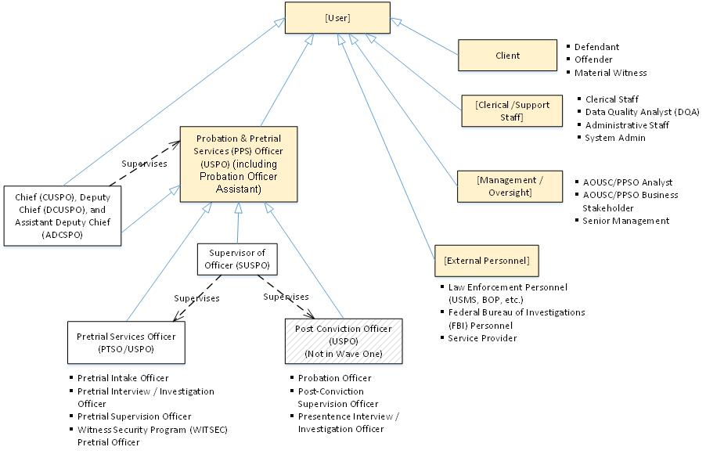

Figure 6. User Roles
Below is a description of the PPS Case Management System Users:
User | Description
- Probation & Pretrial Services (PPS) Officer (including Probation Officer Assistant) | A PPS Officer performs both pretrial services and post-conviction duties.
- Pretrial Services Officer | District line officer and client case manager with direct responsibility for intake, the bail investigation / preparation of the pretrial (bail) report, and/or supervision of individuals for the duration of the federal criminal matter until execution of sentence and (optionally, through self-surrender). Helping to support the Federal Court System before a trial begins through case is dismissed, sentencing, and/or self-surrender. Collaborating with the US Attorney, Federal Defender/Retained Attorney, Community, and Judicial Officer to determine if there are conditions that may allow a defendant to be released safely into the community while recommending a bond that may mitigate any potential risk of flight.
- Pretrial Intake Officer | A pretrial officer that performs intake functions.
- Pretrial Interview / Investigation Officer | A pretrial officer that performs the pretrial interview and investigation
- Pretrial Supervision Officer | A pretrial officer that performs pretrial supervision.
- Witness Security Program (WITSEC) Pretrial Officer | A pretrial officer that performs pretrial activities related to a client in the witness security program.
- Post-Conviction Officer | District line officer and client case manager with direct responsibility for intake, the presentence investigation/report, and/or supervision of individuals for the duration of post-conviction supervision. Helping to support the Federal Court System after conviction or plea of guilt. Collaborating with the US Attorney, Federal Convict/Retained Attorney, Community, and Judicial Officer to determine if there are conditions that may allow a defendant to be released safely into the community while recommending a sentence.
- Presentence Interview / Investigation Officer | A post-conviction officer that performs the presentence interview and investigation.
- Post-Conviction Supervision Officer | A post-conviction officer that performs post-conviction supervision.
- Probation Officer | A post-conviction officer that performs post-conviction supervision after incarceration.
- Intern | A student or trainee who works, to help the officer in order to gain work experience.
- Probation Technician | A person that aid the officer in their duties.
- Supervisor of Officer | District-level, first-line supervisors of pretrial and/or probation officers. Responsible for providing guidance assigning case load (e.g., assigning PTS/PC investigations, assigning PTS/PC supervision cases, reviewing bail/presentence reports, etc.), supporting officers with their supervision of defendants, and reporting on status of cases supervised by their officers. Reviews and approves PTS/PC reports/recommendations. Helping the Federal Court System run smoothly. They oversee the application of principles established by law and policy in each case, and work in partnership with officers to translate these principles into action. They develop the professional skills of their officers; and facilitate the supervision function in their districts. They work with officers to engage in a collaborative case planning and evaluation process for the purpose of devising principled and effective plans for the individual defendant.
- Chief, Deputy Chief, and Assistant Deputy Chief | Chiefs and deputy chiefs are responsible for the quality of office operations. They establish performance standards and create an environment that supports effective supervision. They are responsible for securing resources, establishing written standards, communicate effectively, develop programs, evaluate operations, review noncompliance statistics, reinforce principles, establish effective collaborative relationships, and enhance public relations.
- Clerical / Support Staff | US Court personnel that aid the officer in their duties.
- Clerical Staff | Inactives cases.
- System Admin | Manages users, and grant privileges to user groups with allowable function for the system. System admins can be at the district level or the entire system level. It is assumed that there would be a "Super User" role at the district level with the ability to perform any actions in that district and a "Super User" role for the system that could perform any action for all districts.
- Data Quality Analyst (DQA) | US Court personnel that aid the officer in their duties. Reviews date for a district wide and look for anomalies to fix.
- Administrative Staff | Enters of procurements, purchase orders, and invoices.
- Lab Technician | Perform local drug tests.
- Drug Test Technicians | Perform local drug tests and other support duties.
- External Personnel | Personnel outside of US Courts that interact (either push or pull) with our system.
- Federal Bureau of Investigations (FBI) Personnel | Receives automatic FLASH notice to FBI CJIS (Criminal Justice Information System) when a supervision starts, a modification to supervision expiration, and when a supervision is transferred. Receives FBI NICS (National Instant Criminal background Check System) on background investigation for Firearm Purchases.
- Law Enforcement Personnel | Reviews expedited notification process to local law enforcement agencies as required by the Violent Crime Control Act.
- Service Provider | Exchanges secure messages with officers about clients and service providers can attach invoices for services provided or lab results.
- Client / Defendant / Offender / Material Witness | Anyone arrested on a federal crime or summoned to federal court. Can be a defendant (before plea/verdict) or offender (after plea/verdict). The client submits monthly report.
- Management / Oversight | Managers and other oversight personnel that review the process.
- AO PPSO Analyst | Reviews a collection of reports specifically for the PPSO to aid its analysis and policy decision.
- AO PPSO Business Stakeholder | Reviews the post-conviction dashboard and reporting module, the DSS Pretrial Services module, the DSS Clinical Services module, PPSO Presentence Dashboard, the DSS officer profile dashboard.
- Senior Management | Enters procurements, purchase orders, and invoices.
- Program Reviewer | View only access to the system for program review.

